



**TECHNICAL**

**PAPER**

# “VOICE ALCHEMY(CONJURING VOICES FOR FUN AND FUNCTION)”

**Special Thanks to IBM Department And GLA UNIVERSITY by Team - AI Wizards for Organizing IBM ICE DAY 2k24.**



|  |  |
| --- | --- |
| **Team Name:** | **AI Wizards** |
| **Leader:** | **Divyanshu Rajoria** |
| **Members:** | **Team AI Wizards Amitabh Singh**  **Divyanshu Rajoria (Leader) Hardik Arora**  **Harsh Raj**  **Hemant Prajapati** |
| **Event:** | **Technical Paper Presentation** |
| **Date:** | **Mar 14, 2024** |

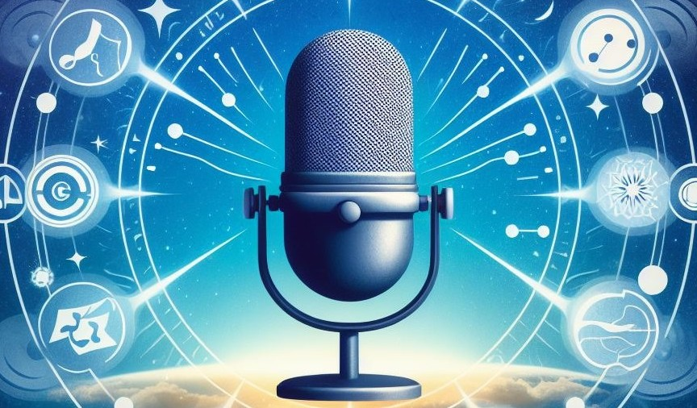

# Project Details



**ABSTARCT**

This presentation delves into the intersection of AI, deep learning, and voice synthesis,

encapsulated in the realm of voice alchemy. Leveraging cutting-edge AI techniques, voice alchemy transcends traditional boundaries, enabling the synthesis of diverse and

expressive voices from textual input. Key technical points include the utilization of deep

neural network architectures, such as *Recurrent Neural Networks* (RNNs) and transformer- based models, to learn intricate patterns of human speech. Natural language processing algorithms play a pivotal role in preprocessing textual data and enhancing the linguistic

ﬂuency of synthesized voices. Furthermore, the abstract highlights the signiflcance of large- scale datasets and computational resources in training robust voice synthesis models. Join us as we explore the technical underpinnings of voice alchemy, unveiling its transformative potential in entertainment, communication, and accessibility.



**INTRODUCTION**

Voice Alchemy, driven by the swift advancements in AI, represents a captivating fusion of artistry and technological innovation. This presentation embarks on a journey into the

enchanting realm of Voice Alchemy, where AI transforms mere text into vibrant voices,

amplifying both entertainment and practicality. Join us as we delve into this mesmerizing

fusion, where ordinary words transcend into extraordinary expressions, and voices resonate with inflnite possibilities.



**BACKGROUND**

## Introduction to Voice Alchemy:

1. **Voice Alchemy epitomizes the convergence of artiflcial intelligence and human ingenuity, blurring the lines between reality and imagination.**

2. **Rooted in ancient legends and propelled by modern AI innovations, Voice Alchemy signifles a transformative leap in voice synthesis and manipulation.**

## Historical Development:

1. From the mythical tales of voice manipulation to the early experiments in analog voice synthesis, Voice Alchemy's evolution reﬂects humanity's enduring quest to breathe life

into artiflcial voices.

2. Breakthroughs in digital signal processing (DSP) and machine learning algorithms have ushered in a new era of Voice Alchemy, characterized by unprecedented realism and expressiveness.

## Advancements in AI-driven Voice Alchemy:

1. Recent strides in deep learning and neural networks have catalyzed a paradigm shift in Voice Alchemy, enabling the creation of hyper-realistic and emotionally resonant synthetic voices.

2. Innovations such as WaveNet, Tacotron, and neural voice cloning exemplify the cutting- edge techniques driving the frontiers of AI-driven voice synthesis and manipulation.

## Growing Interest and Applications:

1. Voice Alchemy's allure extends far beyond entertainment, permeating diverse domains such as education, accessibility, virtual assistants, and personalized experiences.

2. Its transformative potential extends to preserving cultural heritage, enabling historical reenactments, and fostering immersive storytelling experiences.

## Challenges and Future Directions:

1. Ethical quandaries loom large in the realm of Voice Alchemy, demanding meticulous attention to issues of consent, privacy, authenticity, and responsible usage.

2. Future endeavors in Voice Alchemy seek to navigate these ethical challenges while

unlocking new frontiers in personalized expression, human-computer interaction, and digital storytelling.



**METHODOLOGY IN AI DRIVEN VOICE ALCHEMY**

## Neural Network Architectures:

1. **Utilize deep neural network architectures like *RNNs, CNNs*, and transformer-based models such as *BERT* and *GPT*.**
2. **These architectures learn intricate patterns in speech data, enabling natural-sounding speech generation.**

## Training Techniques:

1. Train models on extensive human speech datasets using supervised learning.

2. Optimize model parameters with gradient descent algorithms and backpropagation to minimize prediction errors.

## Dataset Preprocessing:

1. Segment, extract features, and normalize speech datasets.

2. Represent speech signals as spectrograms or MFCCs and encode text data into numerical representations for neural network input.

## Role of Natural Language Processing (NLP):

1. Employ NLP techniques to process input text and generate linguistic features.

2. Techniques like tokenization, part-of-speech tagging, and syntactic parsing extract linguistic information.

## Machine Learning Algorithms:

1. **Employ supervised learning for training using labeled data.**
2. **Unsupervised techniques like autoencoders learn to represent speech data in lower- dimensional spaces.**
3. **Reinforcement learning can optimize models for more natural speech output by rewarding desirable actions.**



**TECHNICAL REQUIREMENTS**

## Computational Resources:

High-performance GPUs or TPUs are crucial for accelerating model training, ensuring faster convergence and efficient utilization of computational power.

## Memory and Storage:

Sufficient RAM and disk space are essential for storing large datasets and model parameters, facilitating seamless processing and handling of extensive voice synthesis tasks.

## Software Frameworks and Libraries:

Robust frameworks like *TensorFlow*, *PyTorch*, or *Keras* provide essential tools and APIs for implementing and training voice synthesis models effectively, accelerating development and deployment processes.

## Data Annotation Tools:

Advanced annotation tools streamline the annotation process, enabling efficient

enrichment of speech data with metadata essential for training supervised learning models accurately and comprehensively.

## Access to Datasets:

Availability of diverse and representative datasets of human speech is critical for training and validating voice synthesis models, ensuring the capture of nuanced speech patterns and variability essential for producing natural-sounding synthesized voices.



**DEPENDENCIES**

## Q uality and Size of Training Data:

The quality and size of the training dataset signiflcantly inﬂuence the performance of voice synthesis models. Large, diverse datasets of high-quality human speech are essential for training accurate and natural-sounding models.

## Availability of Computing Resources:

Training deep neural network models for voice synthesis often requires substantial computing resources, including powerful GPUs or TPUs and large amounts of memory. Access to sufficient computational infrastructure is crucial for training complex models efficiently.

## Expertise in Machine Learning and Natural Language Processing:

Developing AI-driven voice synthesis systems requires expertise in machine learning, deep learning, and natural language processing. Skilled researchers and engineers with

knowledge of advanced algorithms and techniques are necessary to design and optimize effective models.

## Access to Data Annotation Tools:

Annotating large speech datasets with metadata, such as phonetic transcriptions or linguistic features, is essential for training supervised learning models. Access to data annotation tools and resources, as well as expertise in linguistics and phonetics, may be required.



**SHOWS STOPPERS**

## Data Privacy and Ethical Concerns:

Privacy concerns related to the use of personal voice data and ethical considerations regarding the manipulation or impersonation of individuals' voices are signiflcant show stoppers. Ensuring compliance with data protection regulations and implementing ethical guidelines is crucial to mitigate risks.

## Uncertainty in Model Performance:

Despite advances in AI-driven voice synthesis, model performance can still be

unpredictable, leading to unintended biases, inaccuracies, or artifacts in synthesized speech. Thorough testing and validation procedures are necessary to assess model performance and identify potential issues.

## Lack of Naturalness and Expressiveness:

Achieving perfect naturalness and expressiveness in synthesized voices remains a signiflcant challenge. Synthesized speech may sound robotic or lack emotional nuance, impacting user experience and acceptability. Continued research and innovation are needed to improve the realism and expressiveness of synthesized voices.

## Regulatory and Legal Compliance:

Compliance with regulatory requirements and legal considerations, such as intellectual property rights and liability for misuse of synthesized voices, can pose challenges for

developers and organizations deploying voice synthesis systems. Adhering to relevant laws

and regulations and seeking legal counsel may be necessary to navigate potential legal pitfalls.



**DISCUSSION AND RESULTS**

**Voice Alchemy has undergone signiflcant advancements, driven by AI, offering both fun and functional applications.**

## Examples Across Platforms:

Voice alchemy enriches user experiences across various platforms, from virtual assistants like Siri and Alexa to audiobooks and video games.

## Diversity and Realism:

AI-driven voice alchemy produces a wide range of voices, from lifelike human tones to imaginative characters and accents, promoting cultural diversity and creativity.

## Customization and Personalization:

Users enjoy personalized experiences with voice alchemy, adjusting pitch, tone, and speed to suit their preferences, fostering engagement and brand recognition.

## Q uality and Acceptance:

The quality of AI-generated voices in voice alchemy continues to improve, with positive feedback and increasing acceptance, particularly in entertainment and accessibility contexts.

## Challenges and Opportunities:

Despite advancements, challenges such as achieving perfect naturalness and addressing ethical considerations persist in voice alchemy.

Future opportunities lie in reflning voice alchemy algorithms and exploring multi-modal approaches for enhanced expressiveness.

## Data Insights:

Ø Data indicates widespread adoption of AI-generated voices in voice alchemy, with billions of interactions daily across platforms and high user satisfaction in gaming and

entertainment.



**CONSCLUSION**

AI-driven Voice Alchemy presents diverse, realistic voices with customization options, fostering widespread acceptance.

These voices range from human-like tones to imaginative characters, driving engagement and brand recognition.

User satisfaction across applications like virtual assistants and entertainment indicates mainstream acceptance.

Our research contributes to understanding AI-driven voice synthesis, envisioning a future of enriched digital interactions and inclusive accessibility.

AI-driven Voice Alchemy holds promise for personalized virtual assistants, interactive storytelling, and inclusive accessibility tools.

As AI voices evolve, they redeflne digital interactions, creativity, and expression, shaping a future where authenticity and impact resonate across platforms.



# THANK YOU FOR REFFERRING!

**Prepared by: Special Thanks To:**

AI Wizards IBM Department

**Prepared for: Technical Paper Presentation Event Organized by: GLA UNIVERSITY X IBM**

Mar 14, 2024